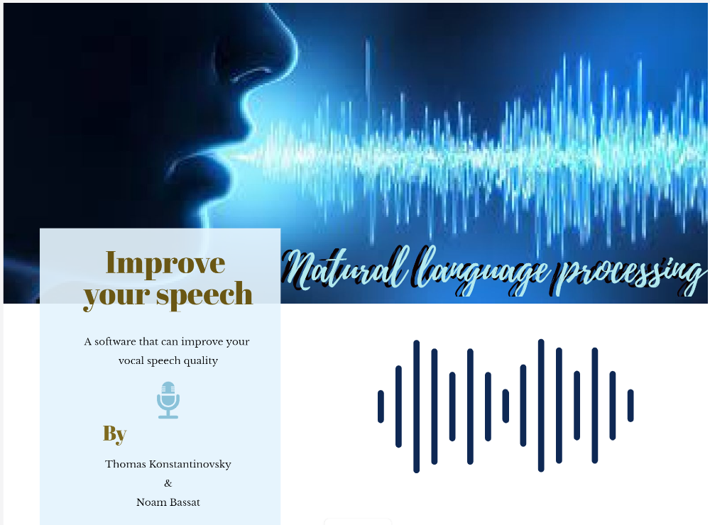

Table of Contents

Introduction 3

Project Assumption 3

The program 5

The Model Structure 5

Backend 6

UI 7

Modules 8

Questions (by chosen topic) module 8

Praat figure Module 8

Graphical Progress Module 9

Advices or compliments Module 9

Speech recognition Module 9

Scores 10

Functionality 11

NLP Tools 12

Simulations 13

Conclusions 16

Bibliography and other sources 17

# Introduction

Researches show that there is a strong connection between different characteristics in speech and the ability to persuade others. This ability depends a lot on the level of confidence that a speaker shows, which can be measured using different speech characteristics.

In modern times in general, and after the outbreak of the corona pandemic in particular, the digital platform is gaining more momentum. You can see a lot of different fields that have been transformed into online. Communication through various online platforms is also in common use in workplaces. Today, the world of social media occupies a large place in daily communication, which evokes the need to improve the performance of verbal communication.

In developing speech recognition and analysis based training, we hope we can improve the speech ability of a person who has difficulty speaking confidently, or of any person who wants to strengthen abilities such as - persuasion, ability to stimulate motivation, trust and interest among listeners / audiences / interviews / dates / employers and more.

This software can suit people in a wide range of fields: sales agents, teachers, people who want to give a speech / lecture, interviewees, dating, people whose work platform is digital (Facebook, Instagram, YouTube, Zoom etc.) or anyone who wants Improve his vocal communication and persuasive abilities.

## Project Assumption

In this project, we relied on a strong connection between different speech characteristics, and the level of confidence and persuasiveness that the speaker demonstrates.

We assumed that by improving the various metrics and characteristics of speech, it would be possible to provide impressive results in the speaker's performance and thereby enabling him to increase his persuasiveness and confidence.

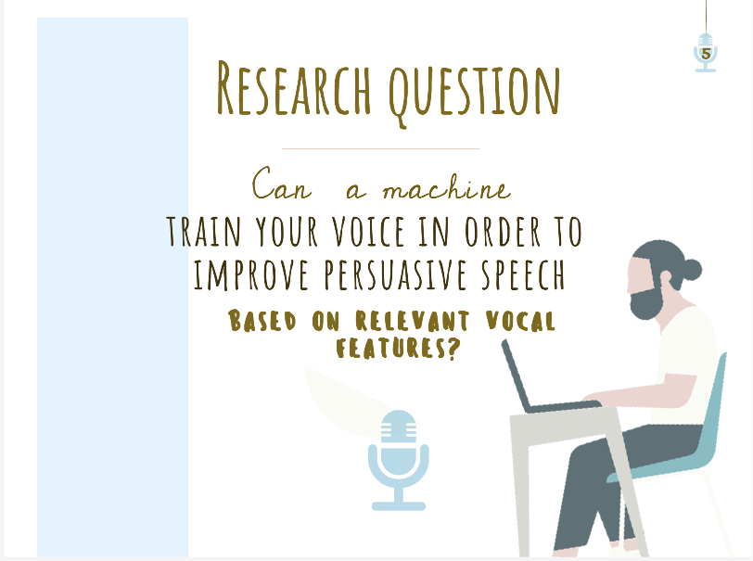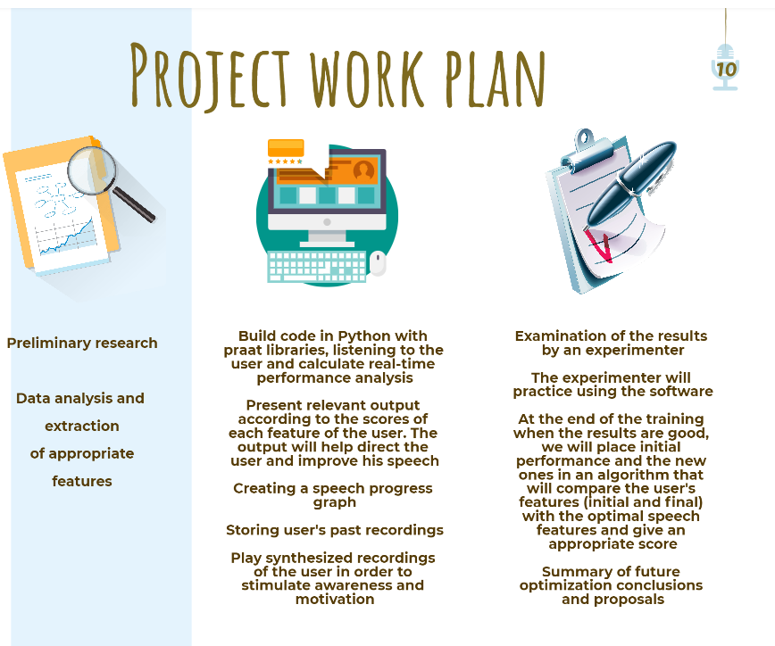

# The program

We took the relevant measurement features from past research in the field.   
In order to obtain a linear graph indicating the relationship between the change in each trait we selected, and the level of confidence the interviewee exhibited, we used a dataset of recordings from a job interview experiment conducted at M.I.T University [1]. We examined which characteristics mostly affect the grade received by each interviewee in his or her job interview. At the grading stage, the scorers did not test knowledge or experience in a particular field, but mostly relied on the interviewer’s communication with the interviewee and his or her vocal characteristics. We chose to focus on several key features: Pitch, intensity-Max, intensity-Min and word repetitions.

We developed the system in Python using special speech processing libraries.

# The Model Structure

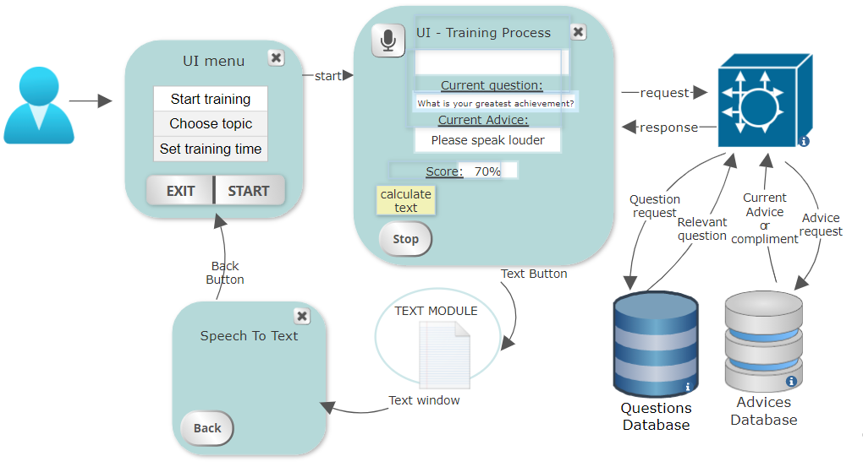

1

4

6

2

Backend

A

B

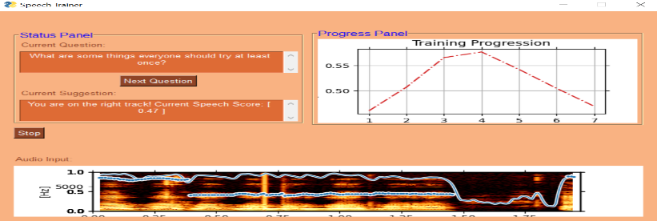

Full text

Top frequent words

7

5

8

3

Note: the numbered arrows are related to the scheme

## Backend

1

1. User recording: From the moment 'start training' has been clicked, the user is recorded. The record was made by using the PyAudio library.

2. Calculation of speech characteristics: Using parallel programming, the software calculates behind the scenes the speech characteristics in real-time and also presents the user some improvement-suggestions or compliments among with his or her current score. We calculated the speech characteristics using the Praat library - ParselMouth.

2

3. Selection of speech characteristics that we calculated and chose to improve: (Based on past research):

3

* Pitch - We found that the Pitch feature is a very influential factor. We found that it can be improved by using descending intonation at the end of a sentence - which makes the user sound more confident [5] . We chose to explain to the user that as long as he is not asking a question, the tone should be lowered at the end of a sentence.

• Intensity Max - We found that speech volume is very important. Very weak speech can be a result of big distance/technical malfunction in the microphone, as well as from insecure and hesitant speech.

• Intensity Min - We found that intensity that is too high also detracts from the user's performance. This can be a result of speaking with a strong emotion (like anger, aggression).

• Word repetitions - We found that repetitiveness of words detracts from user performance. While using rich vocabulary creates better persuasive ability. That is why we chose to emphasize the speaker's text. If the speaker repeats many words, the system shows the word and its number of repetitions, in addition to printing all the spoken text. To calculate this feature, we used the Speech_Recognition library.

4

4. Displays a spectrogram that includes the Intensity and the Pitch metrics in real-time speech.

5

5. Displays a progress graph based on the calculated user scores, in real time.

6. Presentation of questions according to the topic - We have prepared a wide database of questions -a total of 2,258 questions. This database includes questions from job interviews, dating questions and conversations. If the user asks for a new question, the system pulls out another question depending on the topic chosen and in a random form.

A

6

7. Displaying comments and directions - Depending on the feature to be improved, the system displays the appropriate message and guidance. If there are no comments and the metrics look fine, the system randomly displays a "compliment".

B

7

8

8. Displaying the cumulative speech score metric – During the research stage, a gradient boosted regressor was trained to predict the speech score given a vector of features extracted from an audio recording segment.

Each interval of segmentation is unique to the training topic, and based on it; the program extracts the feature vector from the recorded segment and passes it through the model to get the current speech score that is then normalized with respect to the total momentum of the users training progression.

## UI

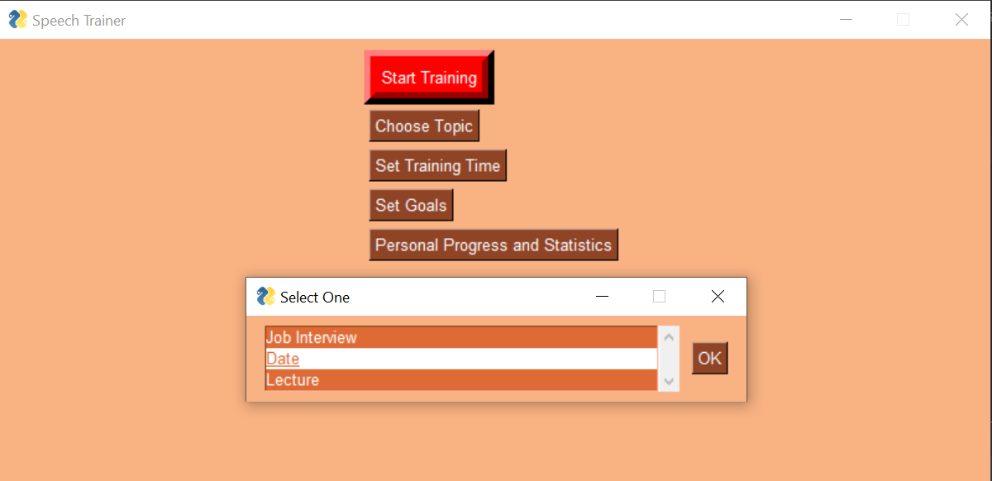**Choose a topic During training**

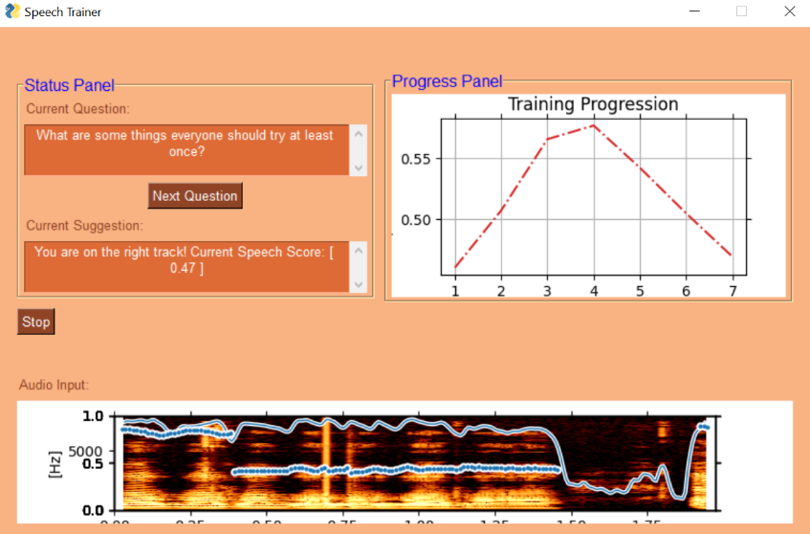

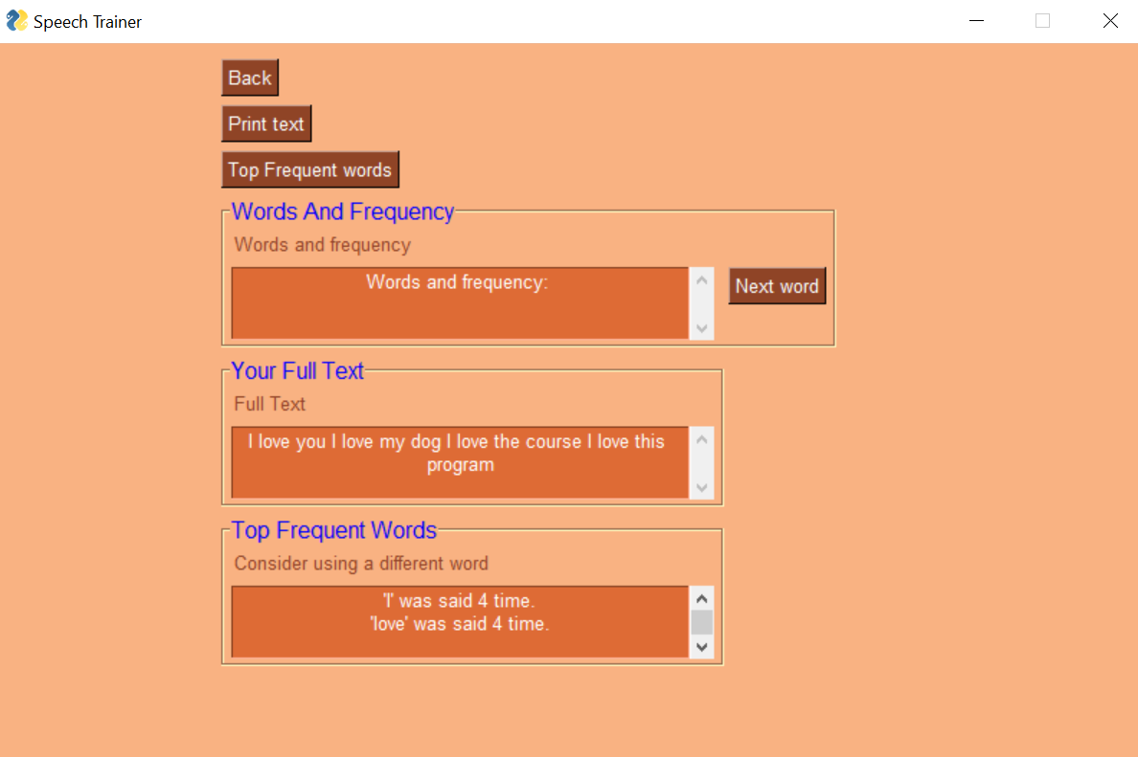**Speech recognition – speech to text window**

# Modules

### Questions (by chosen topic) module

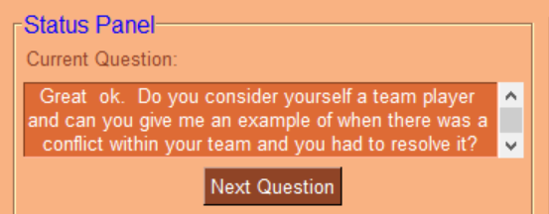

Database of questions from job interviews:

We relied on transcripts of job interviews from a research experiment conducted by MIT University [1]. In total, we collected from the transcript of all the job interviews about 2,098 questions.

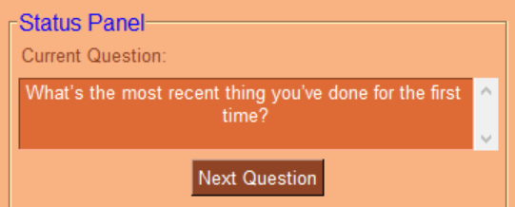

Database of dating questions:

We collected this database of questions while crawling a website: ...... a total of about 160 questions.

### Praat figure Module

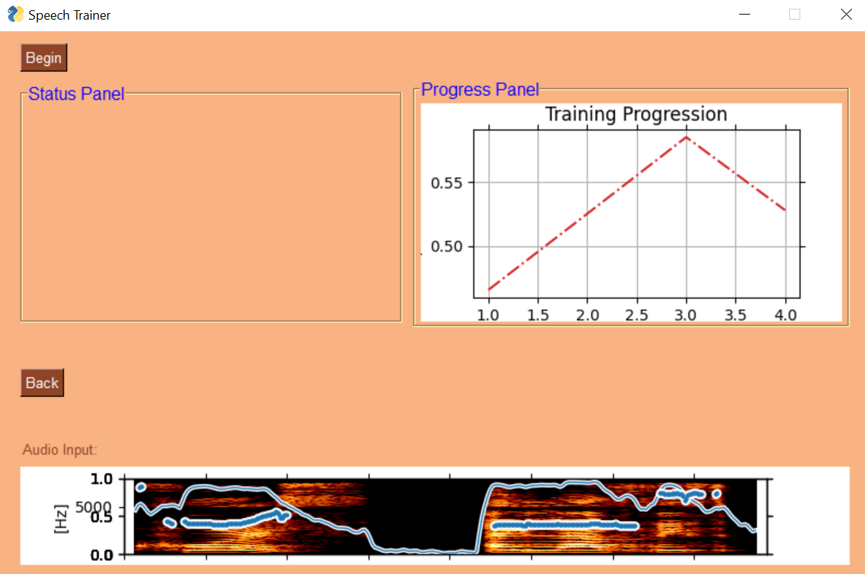

Shows the pitch and the intensity spectrogram in real-time.

### Graphical Progress Module



Shows the user's progress over time, by calculating the average scores.

### Advices or compliments Module

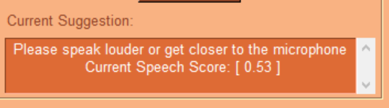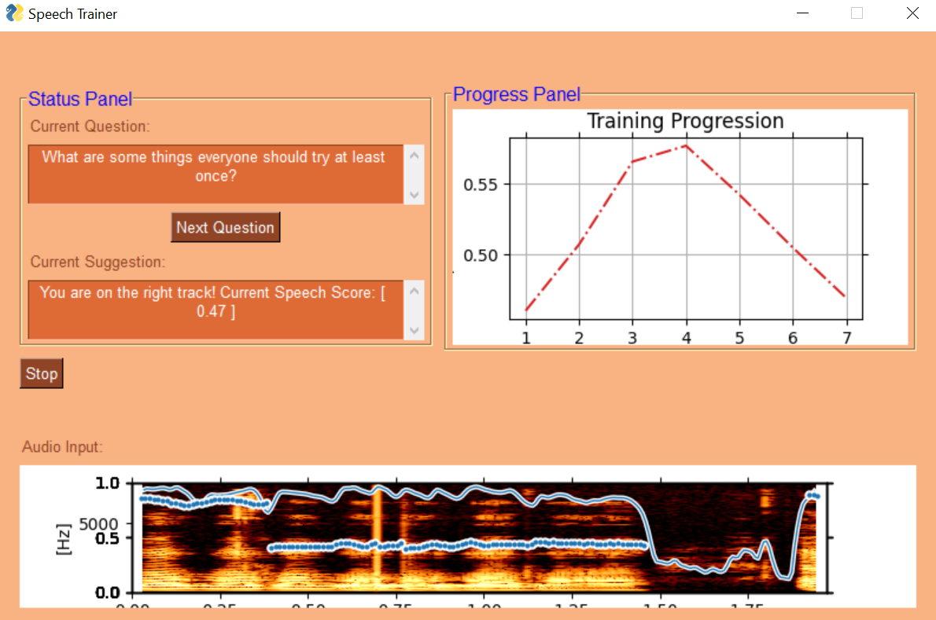

Informs if the user needs to improve some of the features. Otherwise, the program encourages him by generating a random compliment

### Speech recognition Module

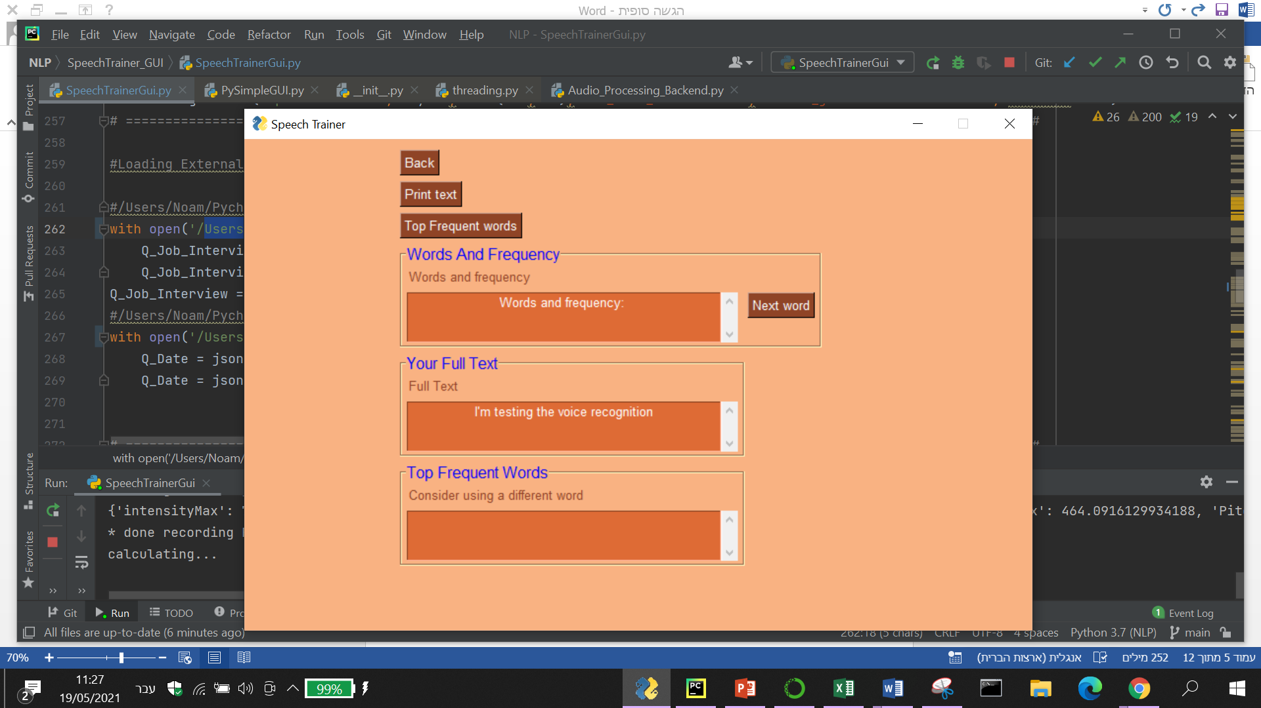Prints the script spoken. If there are any word-repetitions, it presents them along with the amount of repetitions.

Case 1: Short sentence with no repetitions.



Case 2: Presents the repetitions.

### Scores

# Functionality

Generic flow:

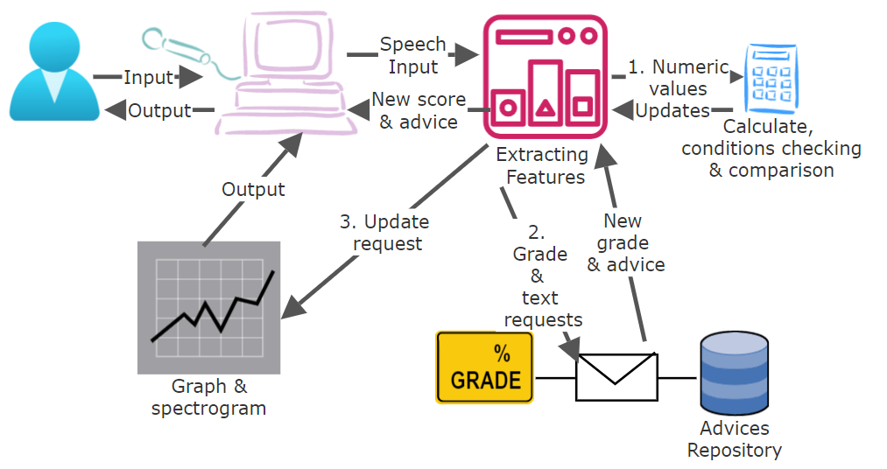

Change question:

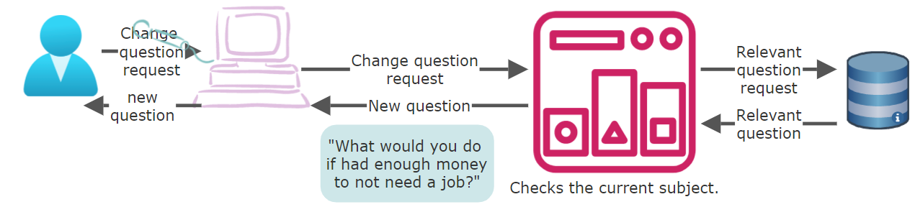

Nervous speaker:

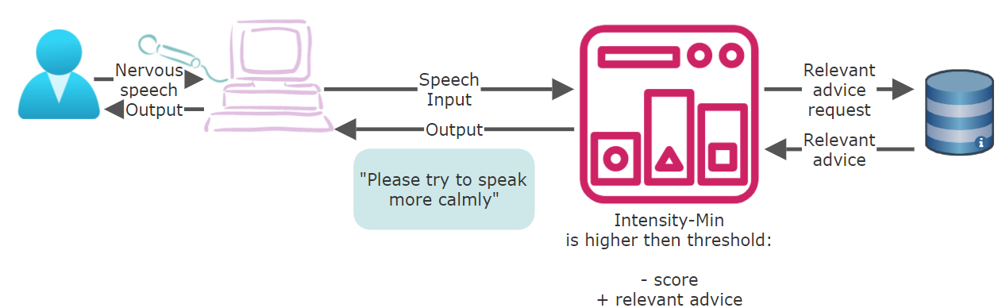

Speech to text:

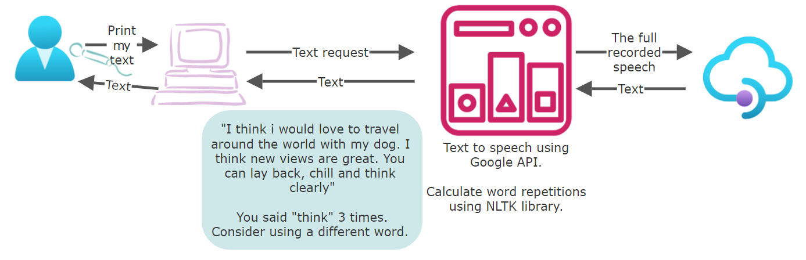

# NLP Tools

**PyAudio -** PyAudio provides Python bindings for PortAudio, the cross-platform audio I/O library. With PyAudio, we could easily use Python to record audio on both Jupyter-Notebook and Pycharm platforms. [6] We initially used this library in order to record the user.  
  
**Wave** - In order to work with the user's recording, we needed to convert it into wave format so that the Praat could recognize it. For this aim, we used the wave module. The [wave](https://docs.python.org/3/library/wave.html#module-wave) module provides a convenient interface to the WAV sound format. It does not support compression/decompression, but it does support mono/stereo. [10]

**Praat-Parselmouth –** We used the Praat library in order to extract and analyze the relevant features from the user's recording in real-time.  
Praat-Parselmouth is Praat in Python - the Pythonic way to use Praat. 'Though other attempts have been made at porting functionality from Praat to Python, Parselmouth is unique in its aim to provide a complete and Pythonic interface to the internal Praat code. While other projects either wrap Praat's scripting language or reimplementing parts of Praat's functionality in Python, Parselmouth directly accesses Praat's C/C++ code (which means the algorithms and their output are exactly the same as in Praat) and provides efficient access to the program's data, but *also* provides an interface that looks no different from any other Python library.'[7]

**Speech Recognition** - We converted speech to text in Python using the [Speech Recognition](https://pypi.org/project/SpeechRecognition/) library. Through this library, we got access to **Google Cloud Speech API.**  
'Speech recognition is the ability of a computer software to identify words and phrases in spoken language and convert them to human readable text. There is no need to build any machine-learning model from scratch, this library provides us with convenient wrappers for various well-known public speech recognition APIs (such as Google Cloud Speech API, IBM Speech-To-Text, etc.)' [8]

**NLTK** – we used the NLTK tool in order to track the word repetitions from the text we already converted from the user.  
'The Natural Language Toolkit (NLTK) is an open source Python library for Natural Language Processing.' [9]

# Simulations

Very nervous speaker

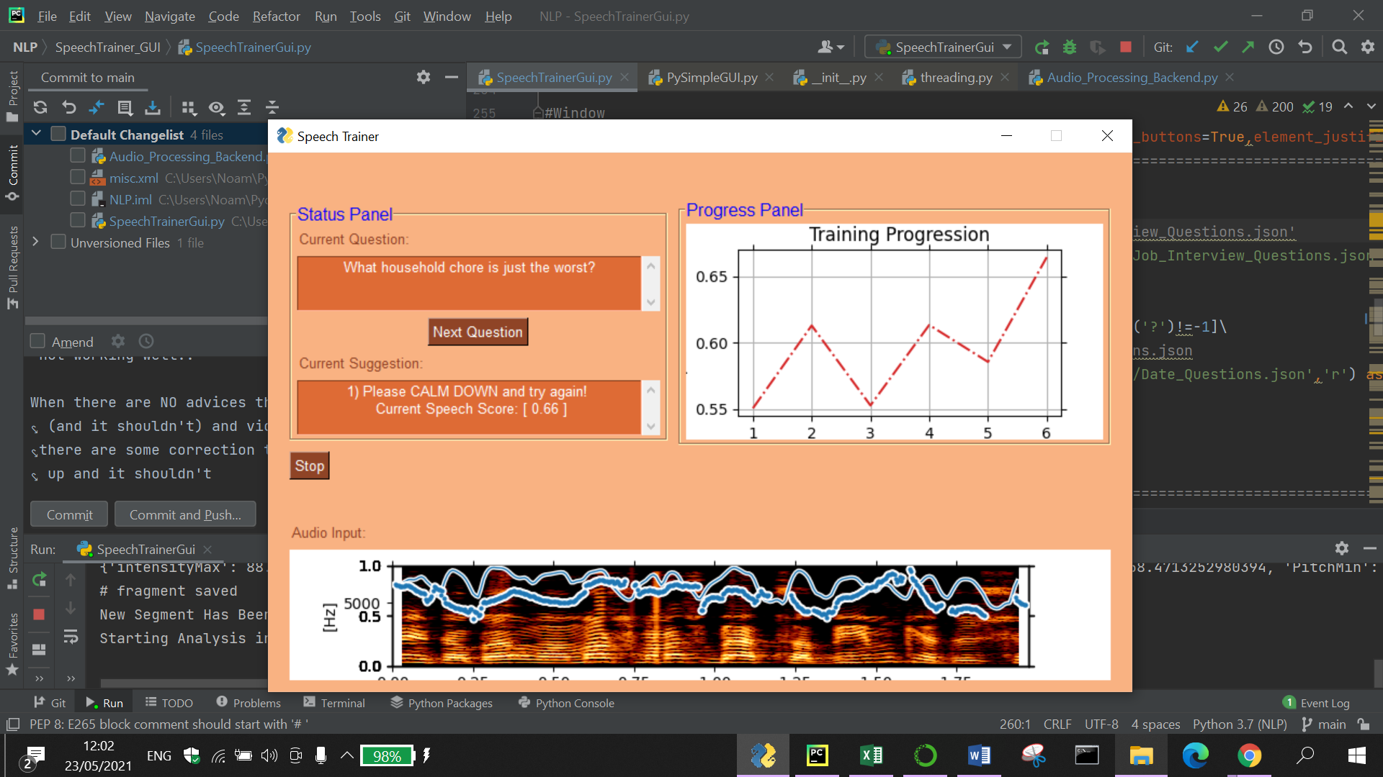

Restless speaker: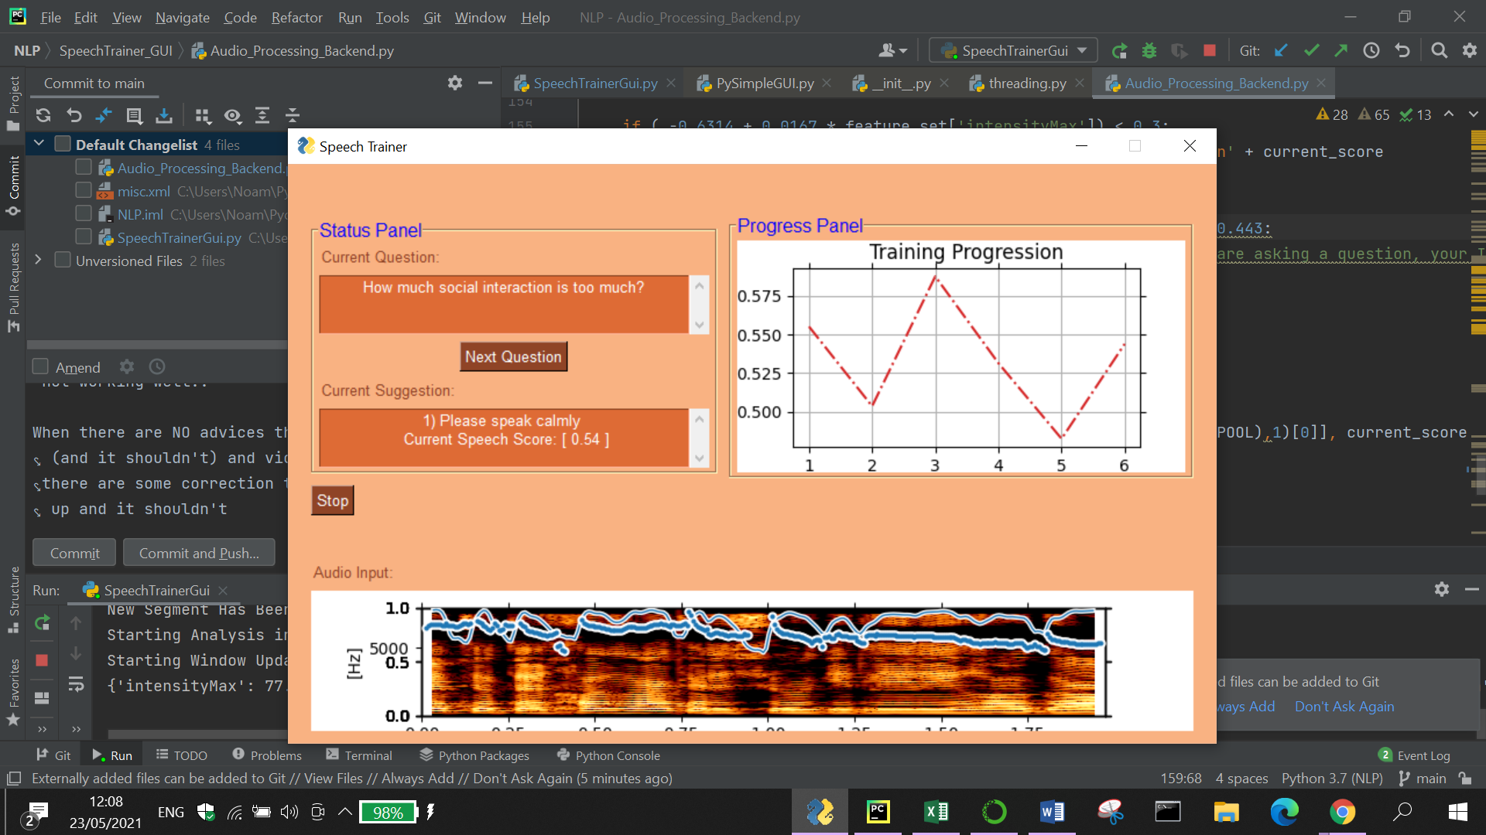

Talking too quietly: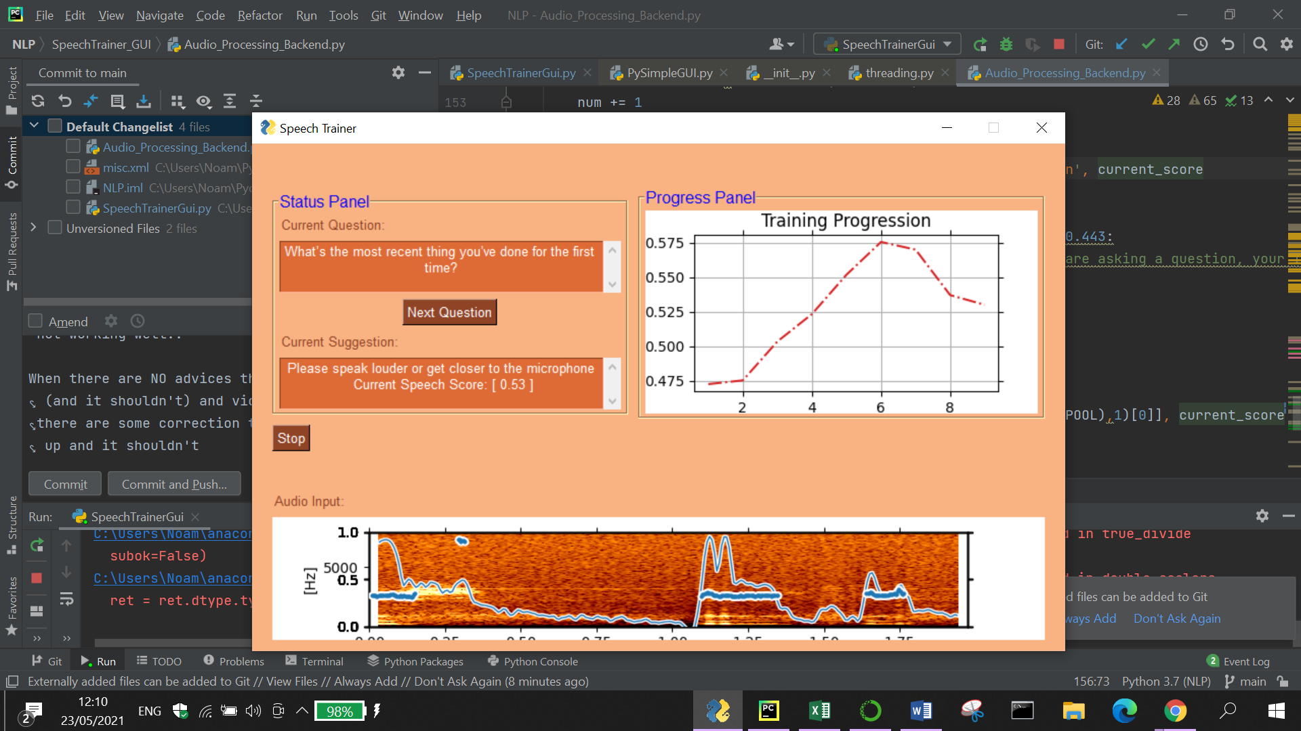

Repetitive words: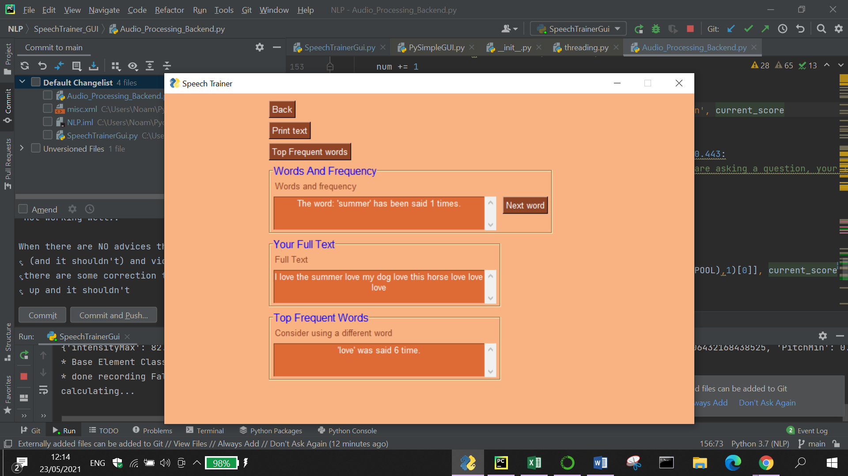

Rising intonation at the end of a sentence: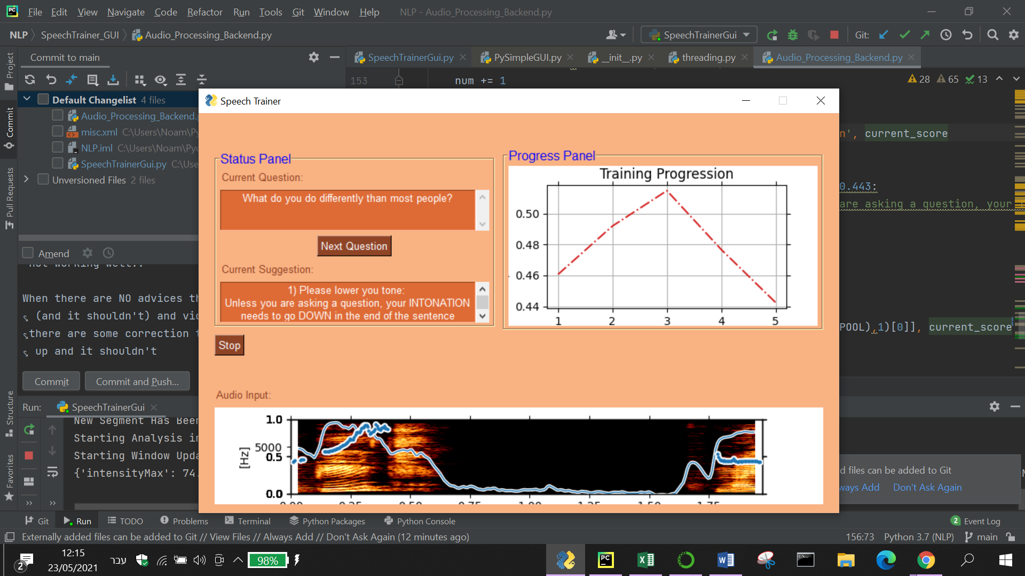

# Conclusions

Our Research question was - "Can a machine train your voice in order to improve persuasive speech based on relevant vocal features?"  
We think that our machine shows a promising start in the direction of real improvement of the voice and textual quality. A strong proof for this assumption can be seen through the score rating change: as long as the user follows the current advices, their score consistently rises. This shows that we succeeded in our major challenge, which was - translating the vocal features into an understandable language, so that the user can efficiently practice on his performance. The fact that we initially selected such features that indicate the level of confidence and persuasiveness in speech (from previous researches) and chose those **that can be changeable** and thus be improved - supports our claim that we succeeded in our mission.  
In order to fully answer the important and more detailed question – '**how much** can this machine improve speech quality?' further work should include way more features, along with tracking many non-confident trainee speakers for a longer period.

# Bibliography and other sources

[1]:I. Naim, M. I. Tanveer, D. Gildea and M. E. Hoque, "Automated prediction and analysis of job interview performance: The role of what you say and how you say it," 2015 11th IEEE International Conference and Workshops on Automatic Face and Gesture Recognition (FG), 2015, pp. 1-6, doi: 10.1109/FG.2015.7163127.

[2] H. S. Shim, S. Park, M. Chatterjee, S. Scherer, K. Sagae and L. Morency, "Acoustic and para-verbal indicators of persuasiveness in social multimedia," 2015 IEEE International Conference on Acoustics, Speech and Signal Processing (ICASSP), 2015, pp. 2239-2243, doi: 10.1109/ICASSP.2015.7178369.

[3] Joshua J. Guyer1, Leandre R. Fabrigar1 and Thomas I. Vaughan-Johnston "Speech Rate, Intonation, and Pitch: Investigating the Bias and Cue Effects of Vocal Confidence on Persuasion" Personality and Social Psychology Bulletin · August 2018 DOI: 10.1177/0146167218787805

**הכוונות בנושא שיפור המדדים:**

[4] Magdin, M., T. Sulka, Júlia Tomanová and M. Vozár. “Voice Analysis Using PRAAT Software and Classification of User Emotional State.” Int. J. Interact. Multim. Artif. Intell. 5 (2019): 33-42.

<https://www.researchgate.net/publication/331881418_Voice_Analysis_Using_PRAAT_Software_and_Classification_of_User_Emotional_State>  
[5] <https://lumen.instructure.com/courses/218897/pages/linkedtext54274>

פירוט הספריות והכלים מעולם ה NLP:

[6] <https://people.csail.mit.edu/hubert/pyaudio/>  
[7] <https://parselmouth.readthedocs.io/en/stable/>  
[8] <https://www.thepythoncode.com/article/using-speech-recognition-to-convert-speech-to-text-python>  
[9] <http://www.nltk.org/api/nltk.html?highlight=freqdist>  
[10] <https://docs.python.org/3/library/wave.html>

**Appendix**

<https://github.com/noambassat/SpeechTrainer>